41.54: a) The radius is inversely proportional to Z, so the classical turning radius is 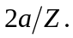
b) The normalized wave function is
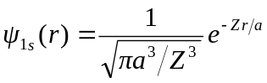
and the probability of the electron being found outside the classical turning point is
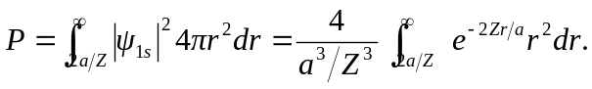
Making the change of variable 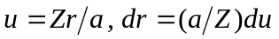 changes the integral to
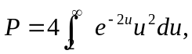
which is independent of Z. The probability is that found in Problem 41.33, 0.238, independent of Z.

